Chapter 13, Solution 16.

To find I_{N}, we short-circuit a-b.
j
8 -j2

a

+ j4 j6 I₂ I_{N}
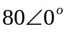V I₁
-
b

(1)
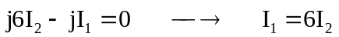 (2)

Solving (1) and (2) leads to
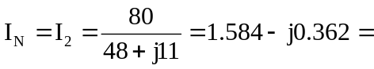1.6246∠–12.91° A

To find Z_{N}, insert a 1-A current source at terminals a-b. Transforming the current source to voltage source gives the circuit below.
j
8 -j2 2
a

+

j4 j6 I₂ 2V
I₁
-
b

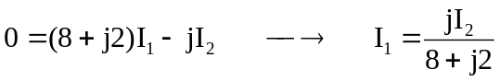
= [j/(8.24621∠14.036°)]I₂ = 0.121268∠75.964°I₂
= (0.0294113+j0.117647)I₂ (3)

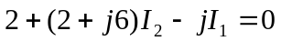 (4)

Solving (3) and (4) leads to (2+j6)I₂ – j(0.0294113+j0.117647)I₂ = –2 or
(2.117647+j5.882353)I₂ = –2 or I₂ = –2/(6.25192∠70.201°) = 0.319902∠109.8°.

V_{ab} = 2(1+ I₂) = 2(1–0.1083629+j0.30099) = (1.78327+j0.601979) V = 1Z_{eq} or

Z_{eq} = (1.78327+j0.601979) = 1.8821∠18.65° Ω

An alternate approach would be to calculate the open circuit voltage.

–80 + (8+j2)I₁ – jI₂ = 0 or (8+j2)I₁ – jI₂ = 80 (5)

(2+j6)I₂ – jI₁ = 0 or I₁ = (2+j6)I₂/j = (6–j2)I₂ (6)

Substituting (6) into (5) we get,

(8.24621∠14.036°)(6.32456∠–18.435°)I₂ – jI₂ = 80 or

[(52.1536∠–4.399°)–j]I₂ = [52–j5]I₂ = (52.2398∠–5.492°)I₂ = 80 or

I₂ = 1.5314∠5.492° A and V_{oc} = 2I₂ = 3.0628∠5.492° V which leads to,

Z_{eq} = V_{oc}/I_{sc} = (3.0628∠5.492°)/(1.6246∠–12.91°) = 1.8853∠18.4° Ω

This is in good agreement with what we determined before.

